Ex.no:9 | MINI PROJECT – IPL SPORTS ANALYTICS  DATA ANALYTICS

Aim:
To clean, transform, store, and analyze IPL cricket match data using Python, MySQL, Power BI and Tableau to derive meaningful insights into match trends, team performance, venue statistics, player performance, toss decisions, and match outcomes.
Algorithm:
- Load the IPL match dataset from the CSV file using Pandas.
- Clean the data by handling missing values, removing duplicate records, and eliminating unnecessary attributes.
- Transform the data by standardizing team names and creating useful derived fields such as Season Sort and Toss Match Result.
- Store the cleaned and transformed dataset in a MySQL database named ipl_analytics.
- Connect the MySQL database to Power BI for data analysis and reporting.
- Create DAX measures for key metrics such as total matches, total seasons, total teams, and toss winner success percentage.
- Develop interactive visualizations to analyze IPL matches by season, matches won by teams, top IPL venues, toss decisions, toss winner results, and player of the match awards.
- Connect the cleaned IPL dataset to Tableau and create separate worksheets for match trends, team performance, venue analysis, toss analysis, and player performance.
- Generate meaningful sports analytics insights from the Power BI and Tableau dashboards.
- End the process.

Architecture:

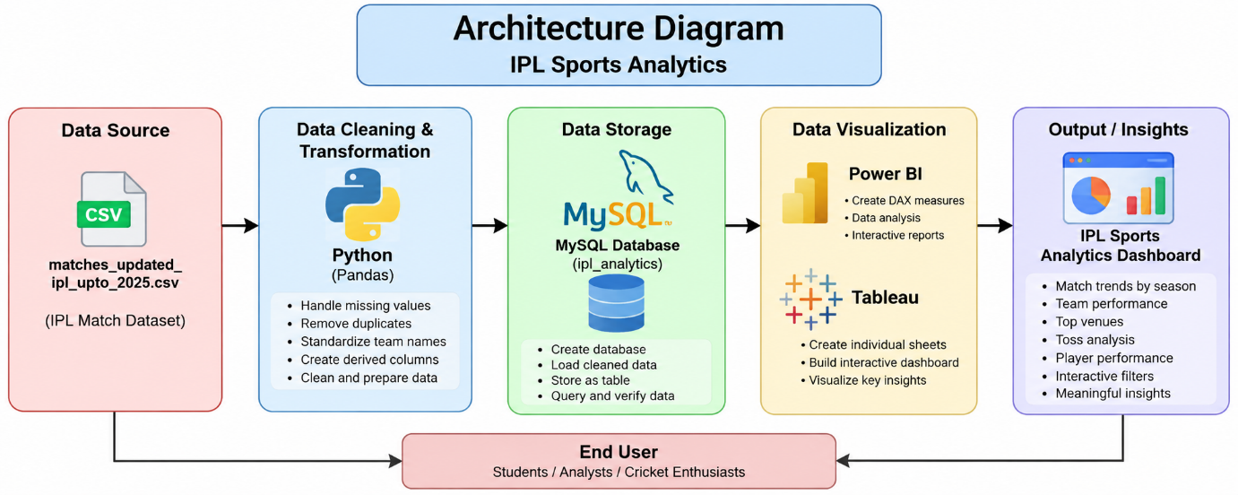

Program:
1. Python – Data Cleaning & Transformation
import pandas as pd
from sqlalchemy import create_engine, text

# Load dataset
df = pd.read_csv("matches_updated_ipl_upto_2025.csv")

# Create a copy for processing
ipl = df.copy()

# Display original shape
print("Original Shape:", ipl.shape)

# Remove unnecessary columns if available
unwanted_columns = [
"umpire1",
"umpire2",
"umpire3",
"method",
"result"
]

ipl.drop(
columns=[col for col in unwanted_columns if col in ipl.columns],
inplace=True
)

# Handle missing values
ipl["city"] = ipl["city"].fillna("Unknown")
ipl["venue"] = ipl["venue"].fillna("Unknown")
ipl["winner"] = ipl["winner"].fillna("No Result")

# Remove duplicate records
ipl.drop_duplicates(inplace=True)

# Standardize team names
team_mapping = {
"Kings XI Punjab": "Punjab Kings",
"Delhi Daredevils": "Delhi Capitals",
"Royal Challengers Bangalore":
"Royal Challengers Bengaluru"
}

for column in ["team1", "team2", "toss_winner", "winner"]:
if column in ipl.columns:
ipl[column] = ipl[column].replace(team_mapping)

# Convert date column
ipl["date"] = pd.to_datetime(
ipl["date"],
errors="coerce"
)

# Create Season Sort column
def season_sort(season):
season = str(season)

if "/" in season:
return float(season[:4]) + 0.5
else:
return float(season)

ipl["Season Sort"] = ipl["season"].apply(
season_sort
)

# Create Toss Match Result
def toss_match_result(row):

if pd.isna(row["winner"]) or row["winner"] == "No Result":
return "No Result"

if row["toss_winner"] == row["winner"]:
return "Toss Winner Won"

return "Toss Winner Lost"

ipl["Toss Match Result"] = ipl.apply(
toss_match_result,
axis=1
)

# Standardize column names
ipl.columns = (
ipl.columns
.str.strip()
.str.lower()
.str.replace(" ", "_")
)

# Display cleaned information
print("Cleaned Shape:", ipl.shape)

print("\nMissing Values:")
print(ipl.isnull().sum())

print("\nFirst 5 Records:")
print(ipl.head())
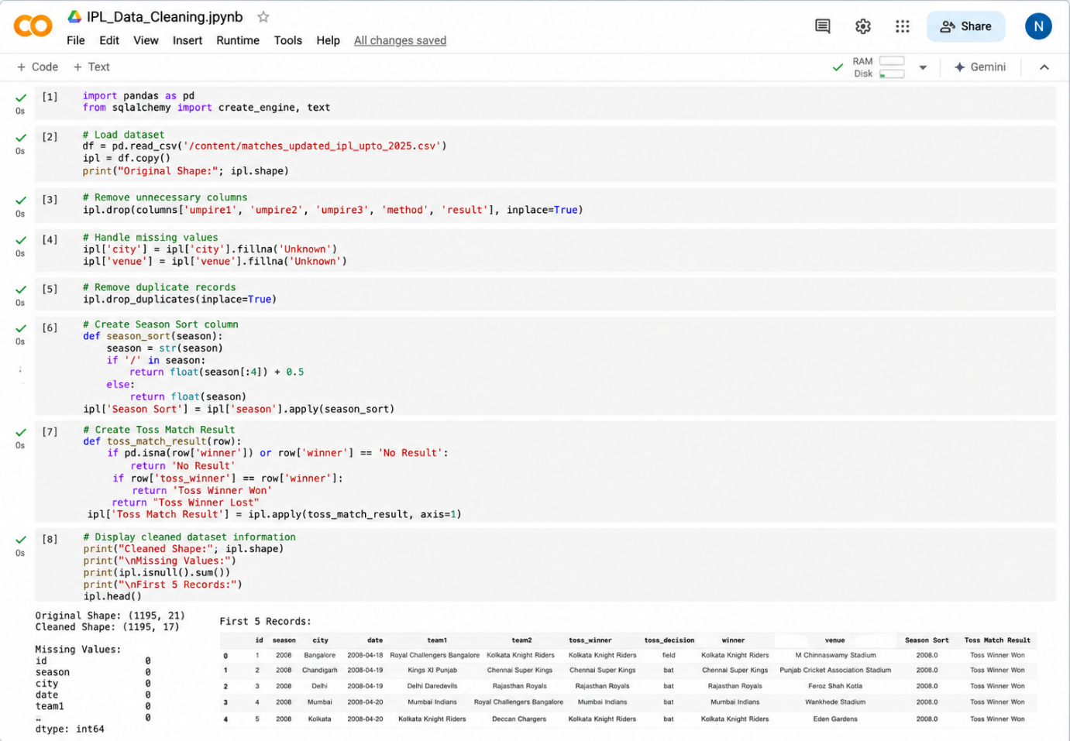
2. MySQL – Database and Data Loading
MySQL Command Prompt:
net start MySQL80
mysql -u root -p
MySQL:
CREATE DATABASE IF NOT EXISTS ipl_analytics;
Python/Jupyter:
username = "root"
password = "YOUR_MYSQL_PASSWORD"
host = "localhost"
port = 3306

# Connect to MySQL database
db_engine = create_engine(
f"mysql+pymysql://{username}:{password}@"
f"{host}:{port}/ipl_analytics"
)

# Load cleaned data into MySQL
ipl.to_sql(
"ipl_matches",
con=db_engine,
if_exists="replace",
index=False,
chunksize=5000
)

print("Data loaded successfully into MySQL.")
Verify:
pd.read_sql(
"SELECT COUNT(*) AS total_matches "
"FROM ipl_matches",
db_engine
)
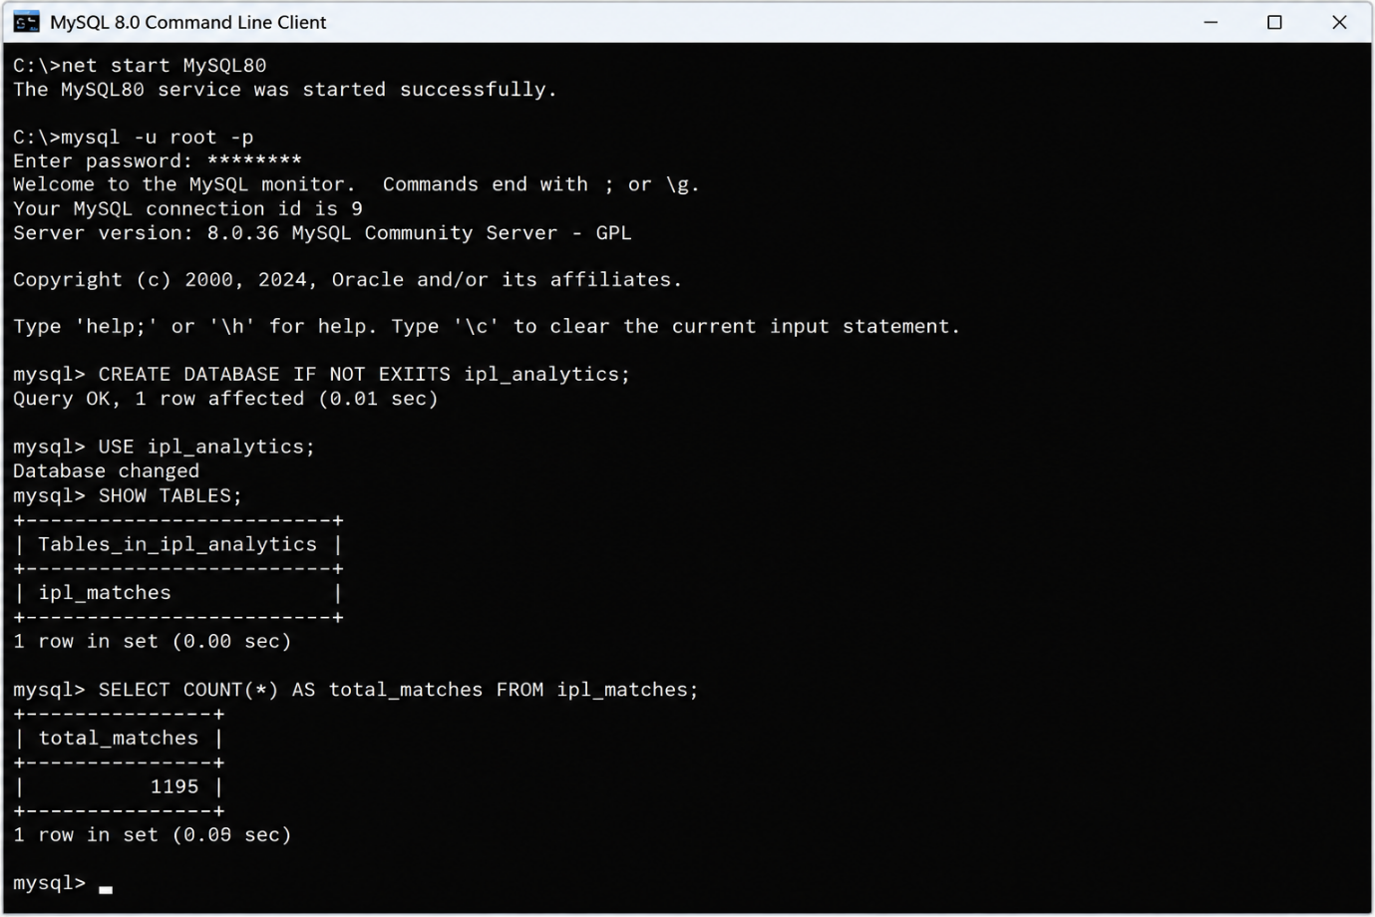
3. Power BI – DAX Measures
Total Matches =COUNTROWS('ipl_matches')
Total Seasons =DISTINCTCOUNT('ipl_matches'[season])
Total Teams =
COUNTROWS(
DISTINCT(
UNION(
SELECTCOLUMNS(
'ipl_matches',
"Team",
'ipl_matches'[team1]
),
SELECTCOLUMNS(
'ipl_matches',
"Team",
'ipl_matches'[team2]
)
)
)
)
Toss Winner Wins =
CALCULATE(
COUNTROWS('ipl_matches'),
'ipl_matches'[Toss Match Result] =
"Toss Winner Won"
)
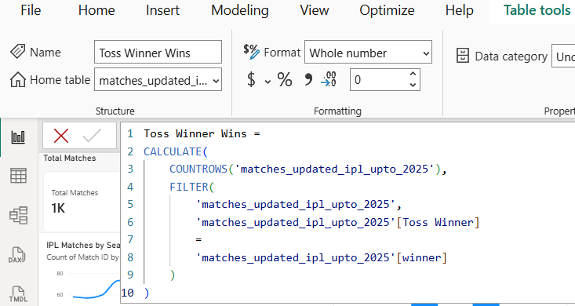
Toss Winner Success % =
DIVIDE(
[Toss Winner Wins],
[Total Matches],
0
)
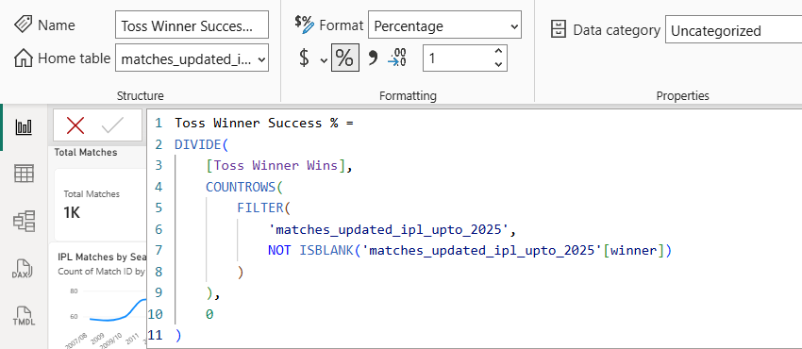
4. Tableau Dashboard
Created visuals in Tableau in separate sheets and created a dashboard for IPL sports performance analysis.
Output:
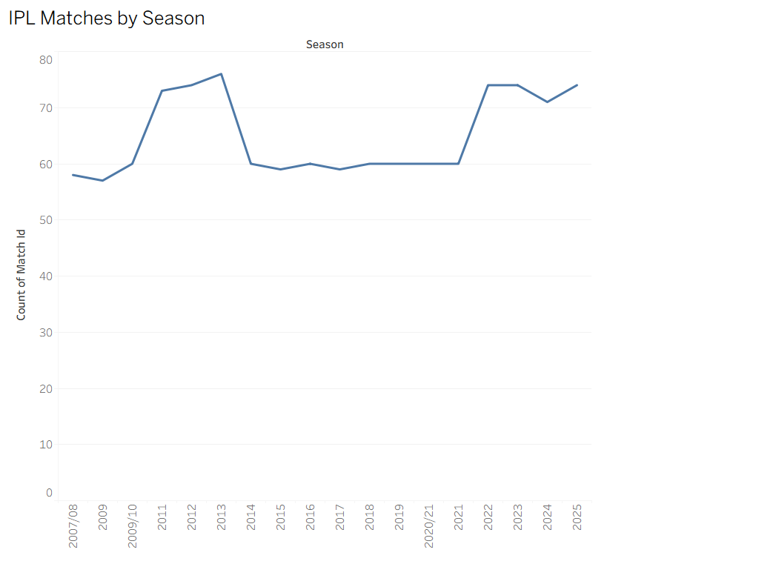

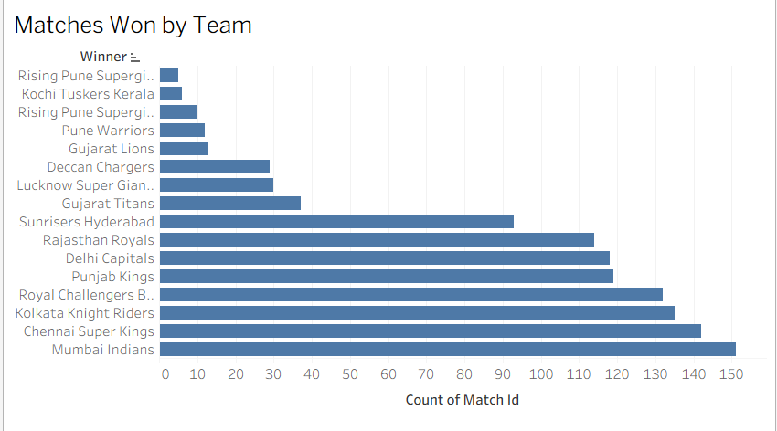

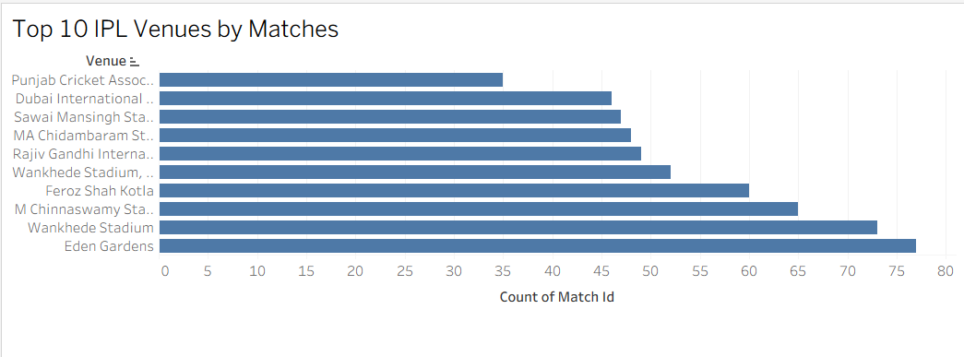

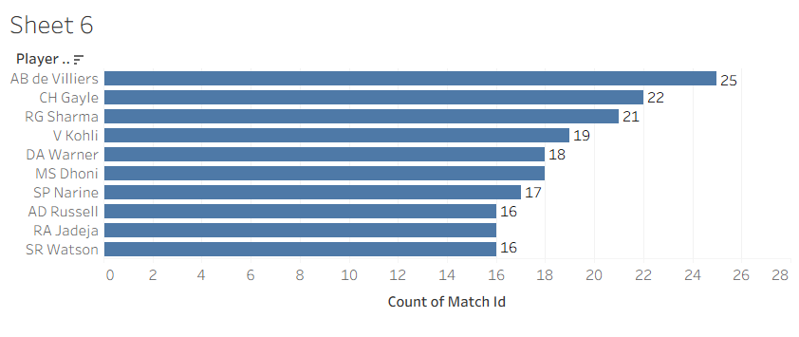
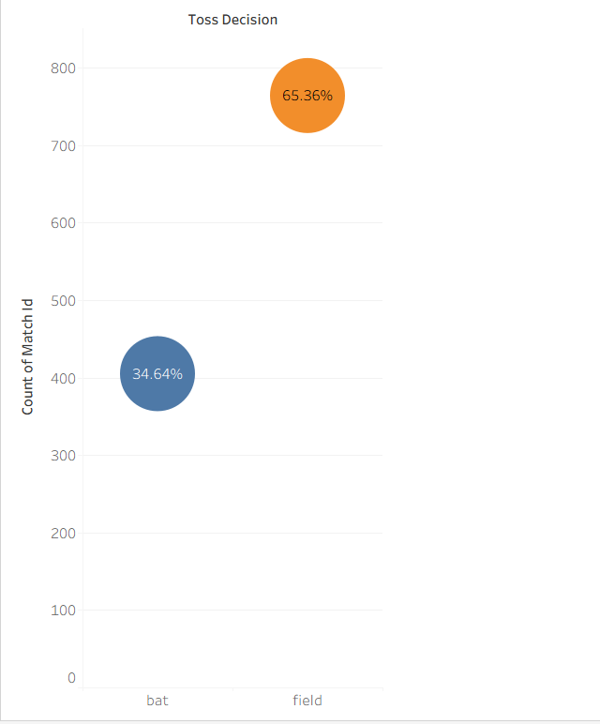

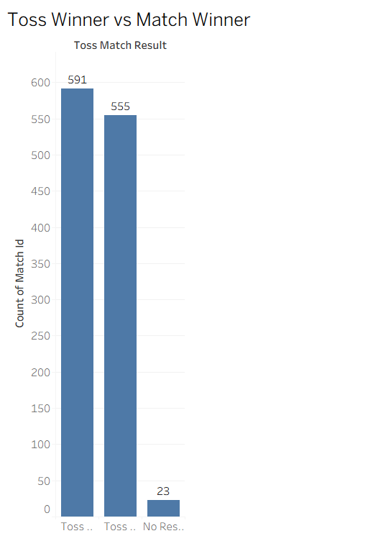
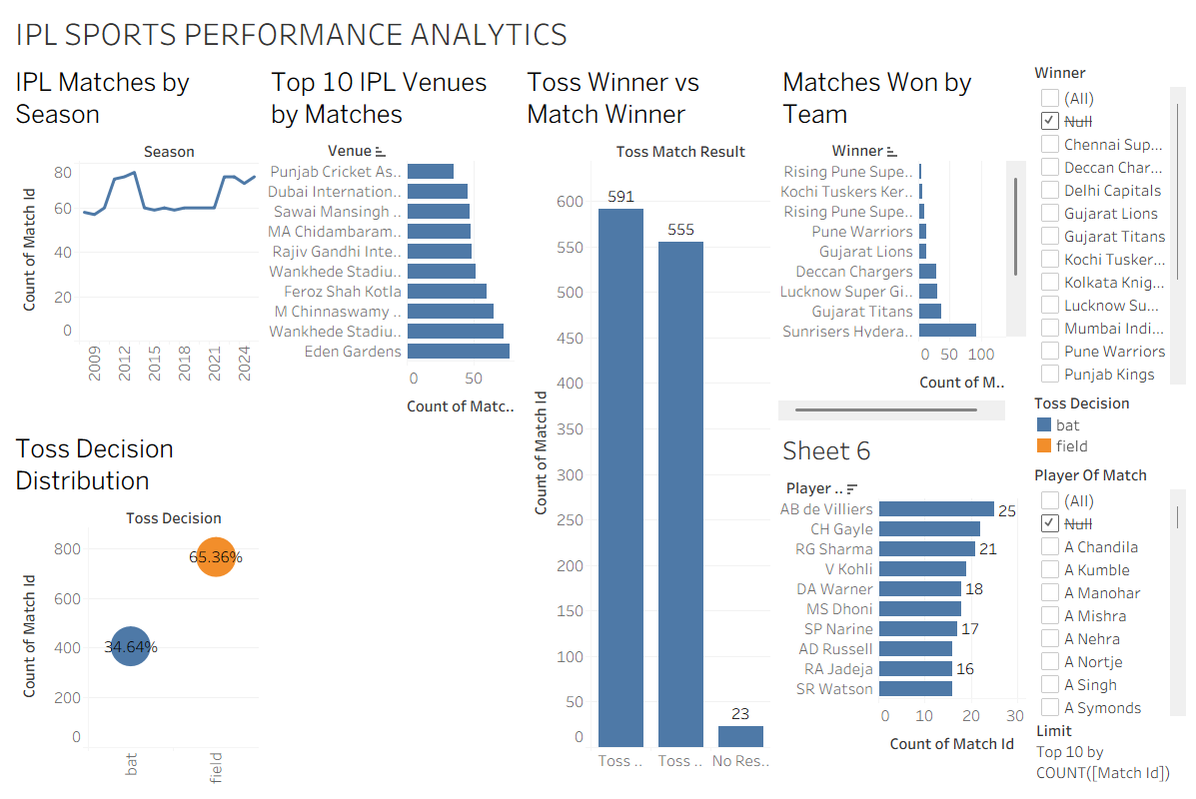

Result:

